# Infrastructure Strategy Smart Airport Report

Internet of Things (IoT) are electronic devices that connects to other networks using many different wireless protocols such as Bluetooth, Wi-Fi and 4G.

The devices are designed to make the user’s lives easier for them, providing a wide variety of purposes, whether it’s used in the physical world or human-centred environments.

An airport managing company has a strong interest in Internet of Things technologies and Mobile Crowdsensing and wants to utilise that to build a ‘smart airport’ to optimise its indoor lighting. I will describe the functional requirements as well as the functional architecture of the system, providing a diagram identifying the various entities of the system and how they interconnect with each other.

During the design process, it’s useful to plan the costing options available for the company to pursue in and budget accordingly. Some ways for the business to cut costs is to only buy enough equipment to make a working system and not to over-purchase on hardware.

The network is following an IPv6 addressing scheme because it’s futureproofing the project and offers a highly scalable address scheme. This is because it provides more unique global, routable addresses.

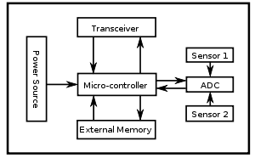Sensor motes will have deployed in key premises of the airport, equipped with embedded luminance sensors. These motes will be used to communicate wirelessly with peers, forming a connected ad-hoc network. This is important because it allows the network to collect sensory data and relay them to the airport back-end.

The controller performs the tasks, processing the data and controlling the functionality of other components in the sensor mote. The transceiver will provide the system with better signal throughout the airport. The external memory in the system will be flash memory due to their cost and storage capacity. The flash memory will store the user memory used for storing application related/personal data. It is important to ensure that there is always energy available to power the system, so having a large power source will be very necessary.

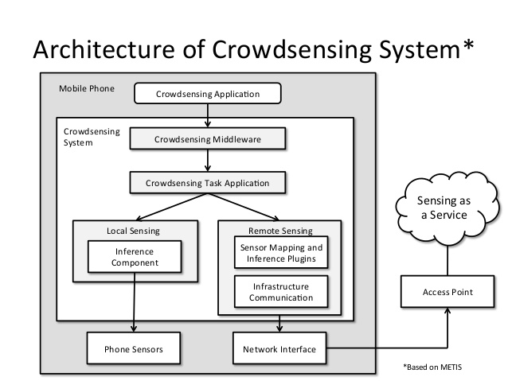The system being created by the airport managing company has a back-end system that will collect all the sensory data and other relevant meta-data and use it to produce a real-time luminance map of the airport based on operations of the indoor lighting systems. This will cause the company to save money because they will be using less energy to power the indoor lights in the airport.

The company will also incorporate Mobile Crowdsensing to the smart airport, to be able to use user smartphone devices to collect information about their embedded light sensors. It will be compulsory for users to download and install the application and give consent for data collection. The business will need to provide the users with an incentive to download and install the application, so providing free Wi-Fi anywhere at the airport should increase the number of people accepting the consent for data collection. Bluetooth beacons will be used across the airport, this is to localise devices within the airport.

There are many ways to collect and store the user data, the strategy I believe will be best for this project is to manually control data collection, such as when the user opens the application on their smartphone.

It is recommended to do participatory crowdsensing instead or opportunistic crowdsensing. This is because we want the users to have the option to take part in the technique or not, forcing the users to download and install the application on their smartphones wouldn’t work because it’s very anti-consumer and some people that will use the airports may not have a smartphone. Giving the users the option will make the company look good in the customer’s perspective because many other rival businesses don’t give them that option and sometimes even collect data without the user’s explicit knowledge.

Mobile Crowdsensing will be used because it will increase the volume of collected data, making the system perform more efficiently and saving energy and money in the process. Giving the users the ability to provide feedback on the Mobile Crowdsensing is extremely important to make sure that there is a good customer satisfaction and helps the company improve their project more effectively.

With data being collected through mobile crowdsensing, it can be a sensitive situation to individuals as it could reveal information such as home and work locations and routes they take when commuting. Ensuring that their privacy and security information is collected safely is therefore important. One way to ensure protection is to provide the users with anonymity, removing their identifying information before sent to the third party.